Lesson 4 Assignment

Laura Bartlett

_________________________________________________________________________

Source code:

##Lesson 4 Assignment##

def play_now ():

## Import randrange function ##

    from random import randrange

    random_number = randrange (1, 3)

    print()

    print("Pick  (1) for ROCK  (2) for PAPER  (3) for SCISSORS.")

    print()

    while(pick := int(input("Your weapon choice (ENTER 1 , 2 or 3): "))):

        if (pick > 3):

            print()

            print("INVALID INPUT! Enter 1, 2 or 3")

            print()

        if (pick == 1) and (random_number == 2):

            print()

            print("My pick: PAPER!!!")

            print("You lose! Paper covers rock!")

            print()

            break

        if (pick == 1) and (random_number == 3):

            print()

            print("My pick: SCISSORS!!!")

            print("You win! Rock crushes scissors!")

            print()

            break

        if (pick == 2) and (random_number == 1):

            print()

            print("My pick: ROCK!!!")

            print("You win! Paper covers rock!")

            print()

            break

        if (pick == 2) and (random_number == 3):

            print()

            print("My pick: SCISSORS!!!")

            print("You lose! Scissors cut paper!")

            print()

            break

        if (pick == 3) and (random_number == 1):

            print()

            print("My pick: ROCK!!!")

            print("You lose! Rock crushes scissors!")

            print()

            break

        if (pick == 3) and (random_number == 2):

            print()

            print("My pick: PAPER!!!")

            print("You win! Scissors cut paper!")

            print()

            break

        if pick == random_number:

            print()

            print("It's a tie!")

            print()

            break

    print("******************************************")

    print("Do you want to play again?")

    print()

## Defined main funtion ##

def main ():

    print()

    print("Let's play rock, paper, scissors!")

 ## "Do you want to play?" loop ##

    choice = "y"2

    while choice.lower() == "y":

        play_now ()

        choice = input("  y/n: ")

        print()

    print()

    print("Bye!")

    print()

if __name__ == "__main__":

        main()

print("Completed by Laura Bartlett")

Source code screenshot (1 of 2):

Source code screenshot (2 of 2):

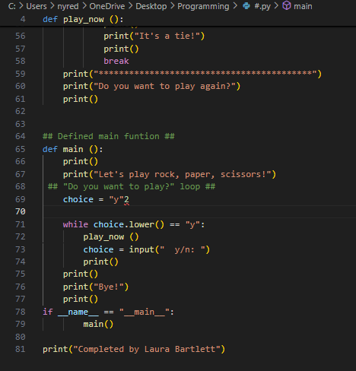

Screenshot of the game:

